**Sana’a**

**UNIVERSITY**



**FACULTY OF ENGINEERING**

**Mechatronics Department**

**Second Year**

**Report**

**Student Report Card Management System**

**Supervision**

Prof. Sami ALmaqtry

Eng. Alia Alhmiry

# Adopted by

**Ibrahim Alkhlydy 202073007**

**Abstract**

The **Student Report Card Management System in C++** is a desktop application coded in a **C++** programming language. The project contains basic functionality that allow user to generate the student report card. This project was created to fasten the distribution of grade record to each student. This will make it easier for the teacher to compute the General Average for the student grade.

The Student Report Card are required in education system that uses some form of reporting to identify student's performance. All Report cards are list of marks scored that analyst the student capabilities to each subject such as: Math, English, Science, etc.

I

Contents

Adopted by 0

Chapter 1 INTRODICTION TO C LANGUGAUE 1

1.1 BACKGROUND 1

1.2 Project Details and Technology 1

1.3 What is the Purpose of Report Card? 2

1.4 BACKGROUND 2

1.4.1 Definitions 2

1.5 What are the Content of a Report Card? 2

1.6 Sample System Screenshots: 3

1.6.1 Login Screen 3

1.6.2 Main Menu 3

1.6.3 Add Student Detail Menu 4

1.6.4 Display Student Detail Menu 4

1.6.5 Update Student Detail Menu 5

1.6.6 Delete Student Detail Menu 5

1.6.7 Student Grade Result Menu 6

Chapter 2 Flow Chart 7

2.1 Flow Chart 7

7

Chapter 3 Conclusion 10

Chapter 4 Bibliography 11

Chapter1 Introduction to C Language

# INTRODICTION TO C LANGUGAUE

## BACKGROUND

## Project Details and Technology

The **Student Report Card Management System in C++** is a desktop application coded in a **C++** programming language. The project contains basic functionality that allow user to generate the student report card. This project was created to fasten the distribution of grade record to each student. This will make it easier for the teacher to compute the General Average for the student grade. This **Student Report Card Management System** is a simple project that benefit students taking computer related course. This is helpful for those who are looking **grading system** related project. This **Student Report Card Management System in C++** can provide new techniques in **C++** programming.

The Student Report Card are required in education system that uses some form of reporting to identify student's performance. All Report cards are list of marks scored that analyst the student capabilities to each subject such as: Math, English, Science, etc.

1

Chapter2 Why to use Phonebook

## **What is the Purpose of Report Card?**

## BACKGROUND

### Definitions

Report cards are a great way for parents to monitor a child performance in school. The sole purpose of report cards is to generate an information from school to parents to report about the overall student's educational progress.

## **What are the Content of a Report Card?**

* Practical Information
* Student Grade
* Transportation Option
* School Contact Information
* Degree of Interactivity

2

Chapter3 Coding of project

## **Sample System Screenshots:**

### Login Screen

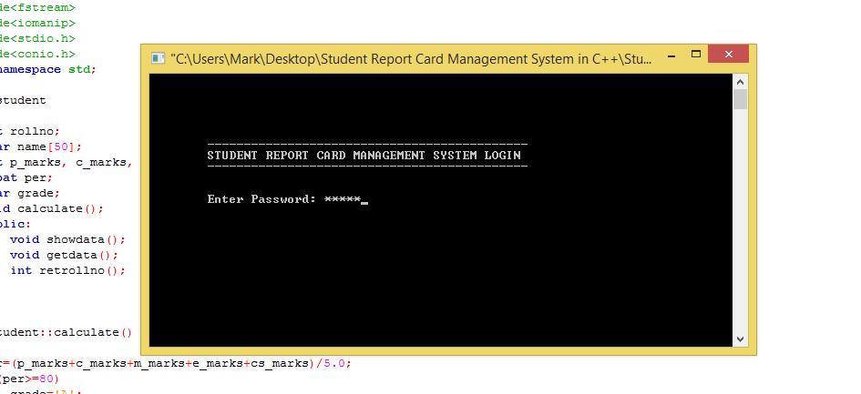

### Main Menu

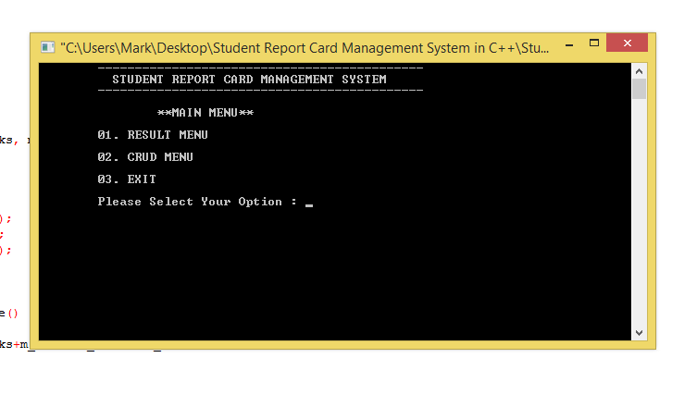

### Add Student Detail Menu

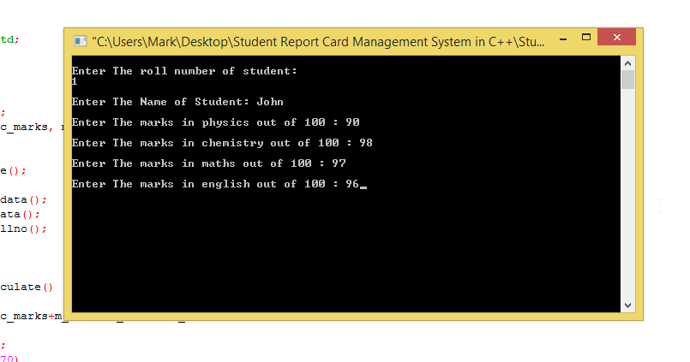

### Display Student Detail Menu

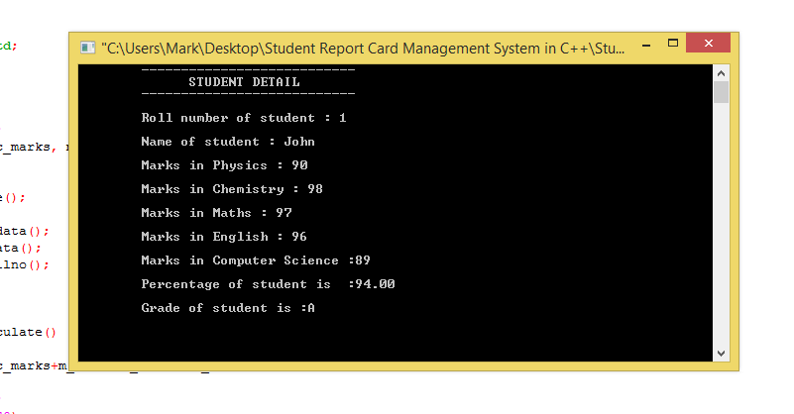

3

### Update Student Detail Menu

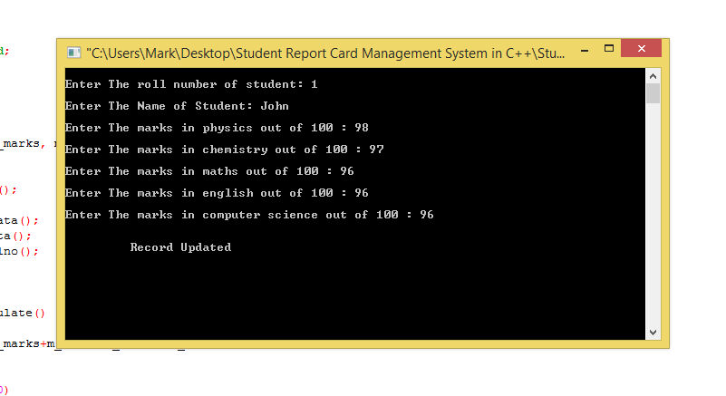

### Delete Student Detail Menu

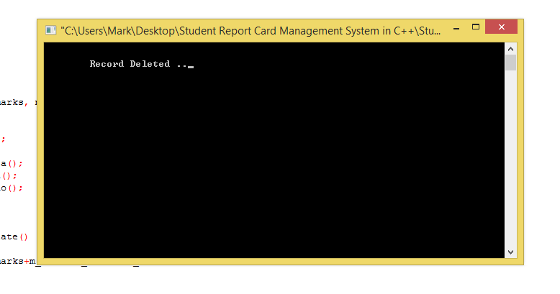

4

### Student Grade Result Menu

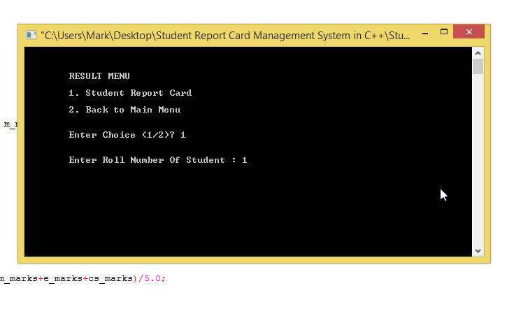

5

Chapter4 Flow Chart

# Flow Chart

## Flow Chart

## 

Start

Class

int rollno

public:

void calculate

float per;

char grade

char name[50];

void getdata();

void showdata()

int retrollno()

void student

else=80 getch

grade='F';

grade='D';

else=70 else=60 else=50 else=40

grade='B'

grade='A

grade='C';

6

void display_sp

while(inFile.read

if(!inFile)

if(st.retrollno

cout<<"File could

st.showdata

cout<<

void ntry_menu

Char ch

Switch(ch)

Case1

Case5

Case4

Case3

Case2

7

Int password

if(pass==***)

Cout<<ACCesss

exit(1)

Else if

Access Aborted...Please Try Again

pass

8

Chapter5 Conclusion

# Conclusion

The **Student Report Card Management System** was developed using only **C++** programming language. This system is a user-friendly kind of system that can be easily modified. The system provide you a faster and reliable generating of student's grade. It will widely provide a fast computation of student subject grade. Using this system it will automate the distribution of student grade.

9

# Bibliography

|  |  |
| --- | --- |
| [1] | Rajinikanth, "Btech Smart Class," [Online]. Available: http://www.btechsmartclass.com/c_programming/introduction-to-c-programming.html. [Accessed 18 03 2022]. |
| [2] | D. Hemmendinger, "Britannica," [Online]. Available: https://www.britannica.com/technology/C-computer-programming-language. [Accessed 18 03 2022]. |
| [3] | tutorialspoint, "Simply Easy Learning," 2014. [Online]. Available: https://www.tutorialspoint.com/ansi_c/c_introduction.htm. [Accessed 18 03 2022]. |
| [4] | B. Thomposn, "Guru99," 12 02 2022. [Online]. Available: https://www.guru99.com/c-programming-language.html. [Accessed 18 3 2022]. |
| [5] | P. Labs, "Programiz," [Online]. Available: https://www.programiz.com/c-programming. [Accessed 18 03 2022]. |

I0